**Program No.06**

**Program title** ir remote and ir sensor

**Aim**

To on motor using ir remote

**Hardware Required**

Arduino board

Servo motor

Ir remote

Ir sensor

**Circuit**

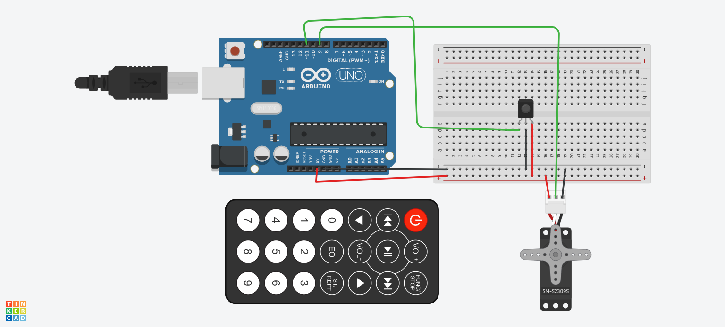

**Code**

#include<Servo.h>

#include<IRremote.h>

int rec_pin =11;

IRrecv irrecv(rec_pin);

decode_results results;

Servo myservo;

void setup()

{

Serial.begin(9600);

irrecv.enableIRIn();

}

void loop()

{

if(irrecv.decode(&results))

{

switch(results.value)

{

case 0xFD00FF:

myservo.attach(9);

Serial.println("start");

break;

case 0xFD609F:

myservo.write(360);

Serial.println("clockwise");

Serial.println(results.value,HEX);

break;

case 0xFD20DF:

myservo.write(-360);

Serial.println("counter clockwise");

Serial.println(results.value,HEX);

break;

default:

Serial.println("un recognised code");

Serial.println(results.value,HEX);

break;

}

irrecv.resume();

}

}